Lockdown Story 6 (Walter Mullan)

Walter is currently resident in the St. Vincent de Paul supported accommodation next door to St. Dominic’s church in Newcastle; he’s been there almost 12 months. Prior to that, he was living on the streets.

I’ve got bi-polar disorder so getting out for walks is really important for my mental health. Although it was still possible to get out when lockdown began, I couldn’t do it as much. I struggled a bit with my mental health, cooped up with my own thoughts, stewing over things. But the staff here was amazing and it really helped to talk to them as well as the Scottish guy who lives downstairs.

It was good to chat to people but I found it also helped to write things down. For example, I’d be watching a film and it would trigger something in my head, so I’d jump up and make a note of it. Later on, I’d use some of these thoughts in the poems that I write. I didn’t get much education, so I’ve taught myself to read and write.

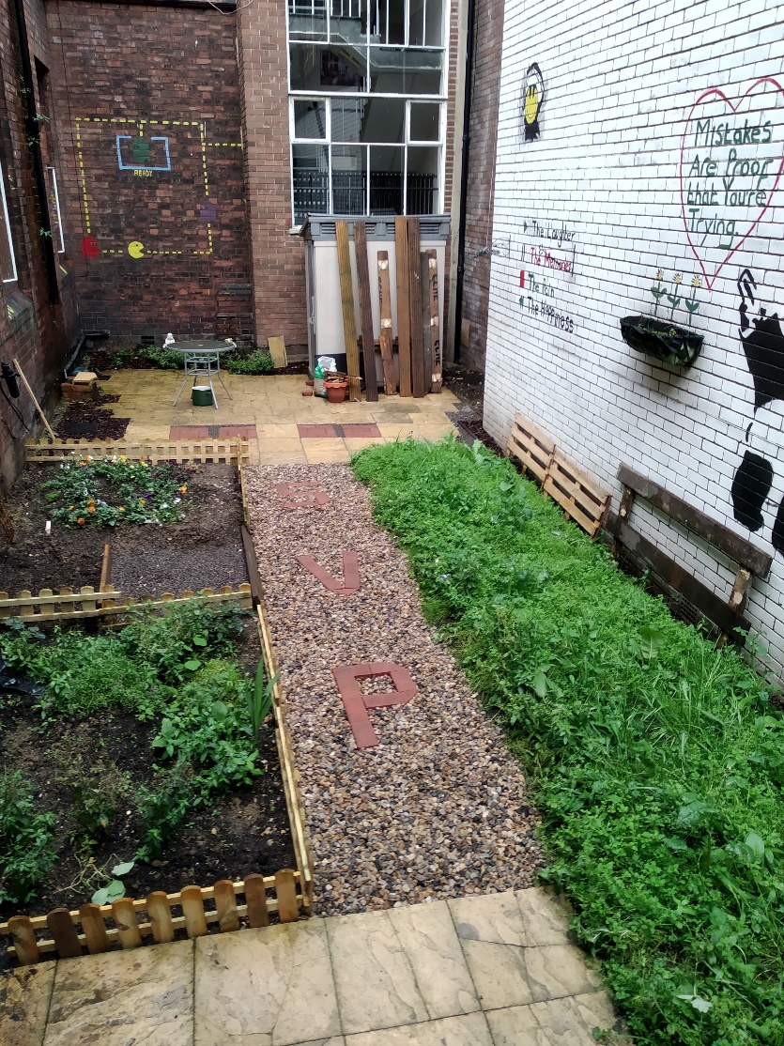
We have a garden in the centre which was a right state. I offered to sort it out because I like working outdoors and I used to run my own business as a landscape gardener. The original plan was just to pave the top end, but we’ve ended up doing more, putting in a path and block paving “SVP” into it. I don’t do it on my own as some of the other lads help. I’m teaching one of them how to do block paving.

I’m still working on the garden, making up some fencing and generally clearing it up some more, but when the weather’s not too bad, me and about 4 or 5 of the other lads have a cup of tea together in the garden between 9 and 10 in the morning. I’m a bit of a perfectionist, a bad job reflects badly on me, so I want to get it as good as I can. I might even start up my business again!

