Holy Island: A Trinity of Churches

Allow around an hour or even longer to allow pause-and-reflection time.
You can, in fact, take the churches in any order – this version starts at St Mary’s Church of England church – the furthest away – and brings you back via St Cuthbert’s Centre (URC) to end at St Aidan’s RC church.
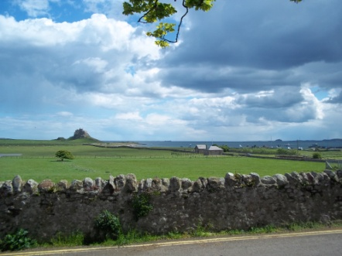
The Walk starts at the coach park so if you have come by car, head into the village and turn left at the Lindisfarne Hotel (the coach park/ disabled parking is well-signed). Turn left at out of the coach park and, before you start the walk, look out over the countryside and breathe in some of the fresh, clean air to start you off.

Continue to your right to the next junction – left takes you to the Castle – but we go right towards the village. Carry on past the National Trust shop on the left and Scriptorium on the right and turn left at the junction towards the Priory.

You will come to the English Heritage building on the right and can decide whether you want to pay to go into the Priory – but it is possible to visit St Mary’s without going into the Priory itself.

Go through the gate and take a short detour to the statue of St Aidan. No one knows the exact location of the church of his time but it is likely that it is in the vicinity of the much later priory and church. Pause and reflect on Aidan – travelling all the way from Iona to a strange land where he did not speak the language or understand the customs and where he had been told people were too barbarous to receive the Gospel!
Give thanks to God for his coming with the light of faith that endures to our own day.
You might like to use the following prayer (or use your own words)

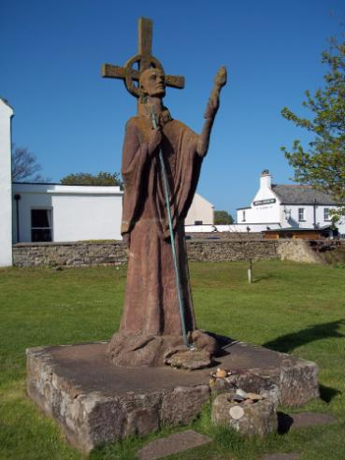
O God, Creator of Light,
you kindled in our brother, Aidan
a fire that burned with love for you
and a zeal to share your Word with the people of his age.
A millennium and a half later,
that light continues to burn-
that Word continues to be proclaimed.
Guide my/ our steps and my/our thoughts
that we might cherish the heritage of faith we will find today
and return to our homes inspired
to share in Aidan’s mission of sharing your love
with those whom I/we meet.
+

St Mary’s Church
Depending on the time of year, as you enter the church, look up and you may see swallows feeding their young.
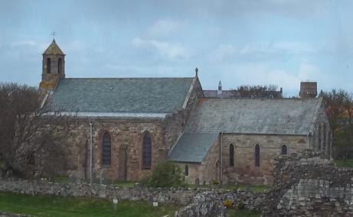
If you do – or even if you just spot the nest, you might like to ponder briefly these words:
Even the sparrow finds a home,
and the swallow a nest for herself,
where she may lay her young,
at your altars, O Lord of hosts,
my King and my God.
Psalm 84: 3

The church has information about the Island and its early saints around the walls on the far side.
Take time to read through some of it – not just as history but as something God did in this part of the world.

Go into the chancel and look at the Lindisfarne carpet – and reflect on the Gospels from which it is taken – and the love and skill that have gone into creating something beautiful for God.
On the left-hand wall, you will see a small plaque, given by Norway to make peace for the raids of the Vikings that did so much damage to the Island and its monastic communities.
Give thanks for this witness to the power of reconciliation and pray for other trouble spots in the world.
Allow yourself time too, to gaze at the other beautiful art-works that give praise to God.

To one side, you will find candles to light in front of an icon of Mary and the Child Jesus. You may like to bring to mind someone who needs your prayer – who, perhaps, needs light in dark places in their lives. Perhaps this is something you are seeking too… in which case, ask God to enlighten your mind and heart.
Light a candle and spend a few moments in silent prayer asking for your needs and the needs of others you are praying for.

Pass across the chancel to the sculpture of “The Journey” by Fenwick Lawson – depicting the monks carrying Cuthbert’s body from the Island on its long journey around the north of England until it reached its final resting place in Durham Cathedral.
This again is a “gazing prayer” – at the craftsmanship that has gone into the sculpture – and also the story that it represents. Look closely at the figures – walk around the sculpture – and notice what thoughts and feelings it inspires.

When you come out of the church, turn right and follow the path round until a gate leads you out onto a lane. Cross the lane and go through the gate. After a short distance, you will see St Cuthbert’s Island where Cuthbert is said to have gone from time to time to have space away from the community. If time and energy and the tide permit, you might like to cross over to the island to experience the stillness there.
+
St Cuthbert’s Centre
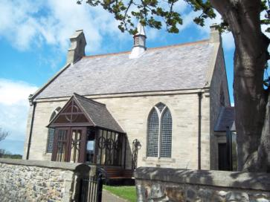
Head back to the lane and continue left until you come to junction and see a small church, St Cuthbert’s Centre.
As you go in, you will see a Prayer Tree with an invitation to add the names of people or things you would like to be remembered in prayer.
Add a name or situation for which you would particularly appreciate prayer.

On a stand, you will also see a print of a contemporary illuminated Bible, The St John’s Bible which is believed to be the first completely hand-written and illuminated Bible from a Benedictine Abbey in over 500 years and almost certainly the first from the United States.
Spend time reading the texts and looking at the illustrations. What strikes you – and why might that be particularly significant for you today?

(You can find out more about the St John’s Bible here: http://www.saintjohnsbible.org/)

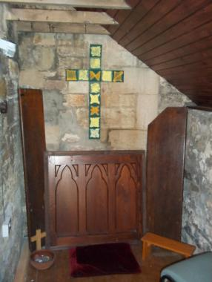
When you come out of the church, head left around the side to the Boiler Room Chapel. This is a tiny space, perfect for a time of intimacy with God.
As you pray, reflect on how little room you need for a prayer space – and think about how you might create one at home if you don’t already have one.

+

St Aidan’s
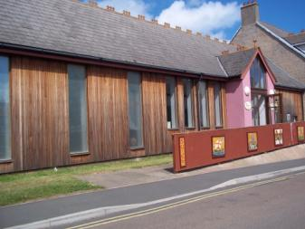

Leaving St Cuthbert’s, turn left, past the winery and shop, then left again to the staggered cross-roads. Straight across and turn right back to the coach part – St Aidan’s is on the left.

As you enter the church, you will see an icon of St Aidan – a gift to the church from a parish in Surrey.
Spend a few moments gazing at the image and, perhaps, imagine a conversation with Aidan – how might he feel to know how Christianity has spread since he first set foot on Holy Island. Think about the many countries where missionaries have gone from these islands – taking the torch of flame kindled by Aidan throughout the world… a work begun by one man fifteen hundred years ago.

Go into the main part of the church where you will see a lit candle which marks the presence of the Blessed (Reserved) Sacrament – the sacramental sign of Christ’s presence).
Look at the stained glass windows on the left – of Aidan – Mary – Peter… great figures in the early life of the Church.
Sit or kneel and speak to Jesus in your own words about your pilgrimage to the Trinity of living and active churches on this Holy Island. What has stayed with you? What has challenged you – or encouraged you? Have you been left with questions – or found answers? Allow time in the stillness for Christ to speak to you.

As your Prayer Walk draws to a close, give thanks for anything that seems to have been a particular gift to you.
Great Shepherd,
we your people, the flock of your pasture,
will give thanks to you for ever;
from generation to generation
we will recount your praise.
(cf Ps79)

We hope that you have enjoyed the Walk.
Please let us have any comments or thoughts that might be of help to future Prayer Walkers.
Contact: kathryn.turner@diocesehn.org.uk

Text © 2013, Diocese of Hexham and Newcastle
Photographs © Kathryn Turner

