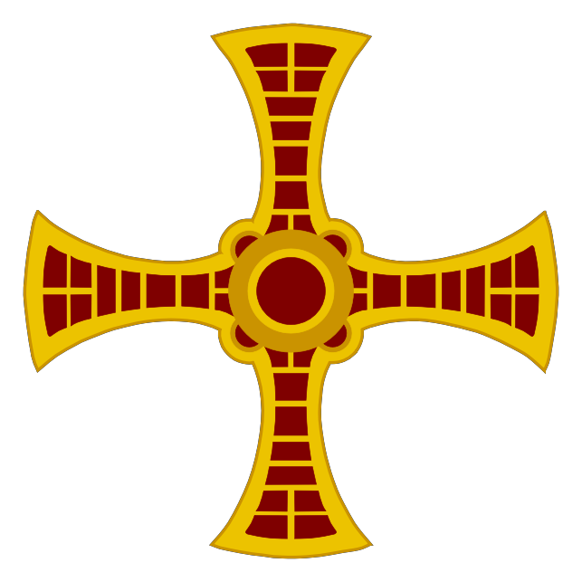

Directory of
Permanent Diaconate
in the Diocese of Hexham and Newcastle

Contents

Page No

Foreword - Rt. Rev. Robert Byrne CO, 4

Bishop of Hexham and Newcastle
- Overview 5
- Selection and Formation 7

Discerning a Diaconal Vocation
  - Selection and Formation
  - The Formation Programme

- Diaconate Ministry 10
  - The Bishop and the Deacon
  - The Deacon and the Diocese
    - The Ministry of the Word
    - The Ministry of the Altar
    - Liturgical Dress
    - Clerical Dress
    - The Ministry of Charity
  - Other Diocesan Issues
  - The Priest, Deacon and the Parish

- Moves and Changes 18
  - New Parish Priest
  - Induction of a Deacon into a Parish
  - Deacons from outside the Diocese

- The Council of Deacons Statutes 21

Foreword

My dear people,

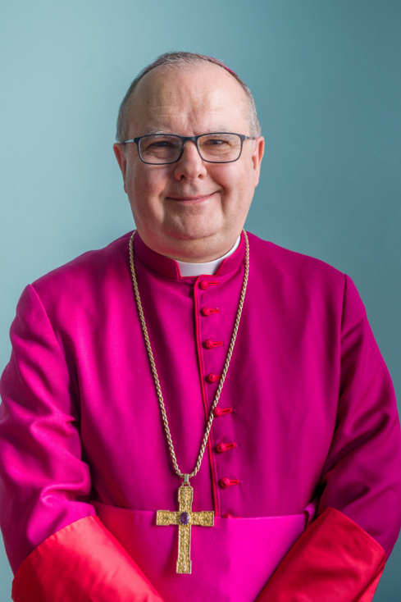
I am pleased to welcome you to the Directory of the Permanent Diaconate in our diocese. The following pages will tell you about what the diaconate is, the process of selection as a candidate for training and a short introduction to the training progamme itself.

It is fifty years since the Permanent Diaconate was restored in the Western Church and sixteen since it was introduced in Hexham and Newcastle. Already our deacons have become a familiar part of the life of many of our parishes and Partnerships. They take their place not only in assisting a priest in a parish but also in more specialised ministries in our hospitals and prisons.

It is a great privilege to serve the Church in the apostolic ministry and it takes much prayer and work on the part of the candidate, the bishop and the formators to discern the call of the Holy Spirit. In the following pages you will find more information about the permanent diaconate and the contact details of those concerned with the different aspects of the diaconate in our diocese

With every good wish and blessing
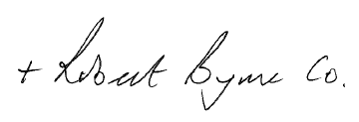

Rt Rev Robert Byrne CO
Bishop of Hexham and Newcastle

Overview
‘Receive the Gospel of Christ, whose herald you now are. Believe what you read, teach what you believe, and practice what you teach.’¹

The Deacon is the Herald of Christ, the Good News. He is a herald in proclaiming the Gospel in all aspects of his life; for all of his life. This is a unique calling; to be the icon of Jesus as he washes the feet of the Church, so the deacon serves the whole Church.² He is sent out by the Bishop to be his instrument in his diocese. He will help the bishop in fulfilling the bishop’s role to teach, sanctify and govern. The deacon, sent to assist those appointed by the bishop, both ordained and lay³, will assist all in fulfilling the munera of the bishop, both within the worshipping Eucharistic community and to all, especially the poor. The herald ship of the deacon is founded on, and strengthened by, his service to the word, the altar and to charity.

The reintroduction of the permanent diaconate by Vatican II has seen developments across the globe which have in their individual ways, expressed something of the essence of this ordained ministry. In all developments the particular relationship between the deacon and the bishop have always been emphasized⁴ which can be seen in the liturgies of ordination, ministries and candidature.

The calling of all through Baptism begins everyone’s journey, a call to ordained ministry continues the journey, the vocation to Diaconate also has the added dimension of being ‘The one sent by the Lord…’⁵. The deacon is not only called but also sent out and in a different way to that of the priest; his is a ‘call and sending out’ in service to the Church, a service to all.

This service to all is the prime concern for the bishop and is summarised in the three munera of the bishop to preach, sanctify and lead the community. This may not be seen as the three munera of the deacon, normally described as service to the word, altar and charity, however, the role of the deacon can be seen as the service to the bishop in assisting him in his munera.

In the above, the last munera of the deacon, the service of charity, built upon and dependant on the first two, is especially relevant when considered in the context of today’s society where those ‘on the fringes’ can be found within the parish community and outside this community. The experience of the ‘original seven’⁶, having apparently settled the discontent with those on the ‘fringes’ of the community (the Grecian speakers), move on to other work, from the martyrdom of Stephen, to the baptising of the Samaritans, by Philip⁷, witnessing again to those on the edges of society.

1 Rite of Ordination of Deacons
2DIRECTORY FOR THE FORMATION OF PERMANENT DEACONS IN ENGLAND AND WALES (1.1)
3Ibid (1.9)
4 DIRECTORY FOR THE FORMATIONOF PERMANENT DEACONS IN ENGLAND AND WALES
5 BASIC NORMS FOR THE FORMATION OF PERMANENT DEACONS, section 3,
6 Acts 6: v5.
7Acts 8: v4

Discerning such a vocation is a process which continues for a life time, especially for a deacon: “The reinstatement of the Permanent Diaconate at Vat II calls for the diaconate “to assume the Church’s responsibility of ‘reading the signs of the times and of interpreting them in the light of the Gospel’”⁸. To carry out this responsibility a deacon’s ongoing formation and understanding of diaconate is critical. It must however begin in the worshipping community where the individual, through his current relationship with the people and clergy, sees himself as being called to this ordained ministry. This process of discernment is to be firstly sought with the parish priest, who acting as the first contact, will start the process and, when and if appropriate, recommend to the diocese that this ongoing discernment be more formally continued⁹.

The individual lives of deacons by their very nature will be different, in terms of family life, work and circumstances in general, however, they must focus continually on their ongoing formation and development throughout their lives and like the first deacons witness to the truth. Deacons are called to be ‘filled with the spirit, set out at noon and going along the road that leads from Jerusalem down to Gaza, the desert road.’ Time, place and direction can often be challenging. For those considering the Permanent Diaconate and those responsible for formation and ongoing formation, great care and discernment must be given.

Therefore, support for deacons must always be paramount, starting from the deacon’s own prayer life to the support from the ‘Council of Deacons’ itself, which is to meet regularly as a body, and also with the bishop. Ordained deacons of the diocese automatically become part of the Council and will support the council in all their work. Eucharistic communities must also understand the nature of the diaconate and their vocation to serve, not to do everything, but encourage and enable the community to grow¹⁰.

The family life of the deacon is no less precious than any other. In all aspects of discernment and formation the care and consideration for wives and families of deacons and those in formation, must form an integral part of the discernment process. The means and formality of such a process and ongoing formation, however, must be accessible and flexible enough to allow wives and families to carry out their own vocation to nurture the family, the ‘miniature Church’, as well as support their husbands and fathers; in such a way the Church benefits from positive divergence in its mission and reflects directly on the permanent diaconate.

8 The Deacon and Gaudium et Spes – Paul McPartland, DPhil (The Deacon Reader – editor James Keating, PhD)
9 See – ‘Selection and Formation’.
10The Deacon and Gaudium et Spes – Paul McPartland, DPhil (The Deacon Reader – editor James Keating, PhD)

Selection and Formation

Discerning a Diaconal Vocation

All priests and communities must look to the future and be alert for good men of faith in our parishes who would be able and generous enough to respond to a diaconal vocation. We need to pray for such vocations and then actively seek out potential candidates.
Any good Catholic man from thirty onwards who is capable of carrying out his family duties, holding down his job and, in addition, is capable of giving the time necessary to enter into the diaconal formation programme is potentially a suitable candidate. An inability to offer much time in the short term to church work (e.g. because of family and work commitments) need not be a deterrent to choosing men who can give some time and otherwise seem well suited to diaconal ministry. Sowing the seeds of a vocation is important, for when work and family commitments change, the seed sown some years back may begin to flourish.

- The candidate must be intelligent enough to follow a normal course of studies without being unduly weighed down by it, healthy enough to carry out the duties of a deacon, with the sort of generosity of character that is still open to being formed, and with a soundness and stability of character that invites trust.

- He must have the right intention – to model himself on Christ the Servant who came not to be served but to serve.

- He must be accepting of the call of the Church – that he be willing to put himself in the hands of the bishop and those the bishop has chosen to carry out the discernment and formation process. No one can claim the right to be ordained. His desire to be ordained is never sufficient in itself; rather he must wait on the decision of the Church.

It normally takes a minimum of one year from the time the Director for the Formation for the Permanent Diaconate is given a candidate’s name to the time that person is presented to the diocesan interview board. If he is perceived as having a possible vocation and accepted for the Diaconate Formation Programme, it will normally take another four years before he is ordained as a deacon.

Minimum Admission Requirements

An applicant must:

  - be a baptised man who is confirmed and has received his first Holy Communion;
  - have been a Catholic for a minimum of five years;
  - be legally a permanent UK resident;
  - be at least 31 at the time of admission to the Formation Programme;
  - normally be no more than 60 by the time he is due for ordination;
  - enjoy good physical and mental health with no condition that would impede his ministry; have the necessary ability to complete the formation programme;

- be reasonably financially secure;
- understand that permanent deacons who are employed or who have been employed are bound by Canon Law to support themselves from their own funds¹¹; (The diocese will meet the cost of the formation programme and reimburse the candidate for travelling expenses.)
- be a parishioner domiciled in a parish within the Diocese for normally at least 3 years.
- if single, have a settled stable life with a good reputation within the community. He must fully understand the charism of celibacy. He must understand that ordination would mean a life-long commitment to celibacy;
- if married, to have been validly married for at least 5 years;
- should his wife predecease him, be willing in normal circumstances to remain celibate for the rest of his life;
- have the full support and consent of his wife, her consent expressed in a handwritten letter accompanying his application;
- enjoy with his family a good reputation within the community;
- be able to give the necessary time to both the formation programme and the diaconal ministry without it being detrimental to his family or working life;
- be presently active and accepted within the Church and parish community;
- be willing to undergo the diocesan formation programme and be involved in on-going formation after ordination;
- be willing to make a life-long commitment to serve the Church according to the model of Christ who came not to be served but to serve;
- be willing to promise obedience to the Bishop and his successors and be willing to accept any pastoral assignment that may be given to him;
- be highly recommended by his parish priest or those who have worked with him in ministry;
- be willing to undergo psychological assessment as to his suitability and to undergo all checks required by the Diocesan Safeguarding Policy prior to formation;
- be willing to undergo a full medical examination;
- be orthodox both in belief and practice, and be willing to take the Oath of Fidelity and make a profession of faith according to the formula approved
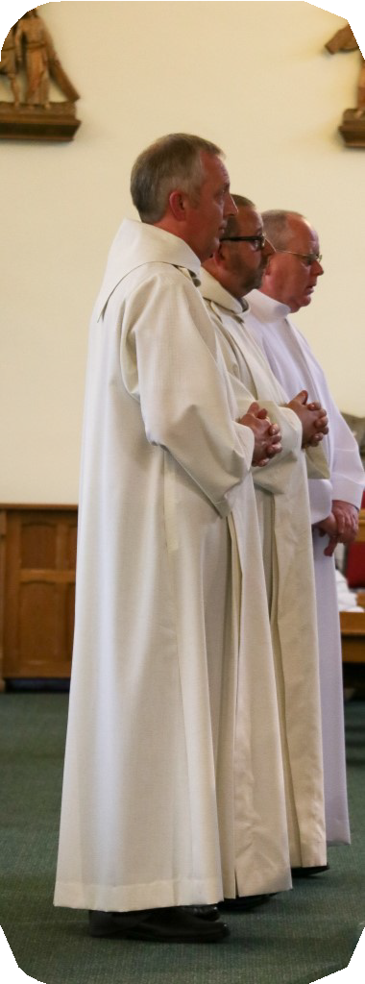by the Apostolic See¹²;
- be dedicated to our Lord in the Eucharist;
- above all he must be a man of faith and prayer.

During the formation programme his parish priest must be willing to co- operate with the formation team in his training. Once a parish priest has decided in the light of the above requirements that he has a suitable candidate to put forward, the next step is to contact the Diocesan Director for Formation. Alternatively, the prospective candidate, having spoken to his parish priest, may contact the Diocesan Director for Formation, Fr. Sean Hall, St. Mary’s, Forrest Hall, NE12 7AB Tel 0191 2684222. Further information can be found on the Diocesan website www.rcdhn.org.uk.

11Canon 281§3
12 Canon 833

Selection and Formation
The process of discernment will include gathering together all the necessary information to complete an Official Application form, the candidate being medically and psychologically assessed, and a review to ensure there is no canonical impediment to the candidate being accepted.

The selection panel meets each year, as required. Should the candidate be accepted, he would join the Permanent Diaconate Formation Programme the following September.

The Formation Programme
This is a four year programme. The first year is a propaedeutic year, initiating the aspirants into a formal prayer life, basic liturgy and a way of thinking with the Church. At the end of the year there is a major assessment and, depending upon the outcome, the student is formally admitted as a Candidate for the diaconate. There follow three more years of formation focused on the human, spiritual, intellectual and pastoral development of the candidate in all appropriate areas of theology, scripture, catechesis, liturgy, Canon Law and other related subjects.

Each year there is an assessment process. If all is well, the candidate is instituted as a reader at the end of the first year of formal training, the following year as an acolyte, and finally ordained a permanent deacon at the end of the fourth year. It needs to be said that the whole programme is part of the discernment process and the purpose of the assessments each year is to facilitate the process of discerning God’s call to the individual candidate. Therefore, acceptance of an individual into the formation programme does not mean acceptance for ordination.

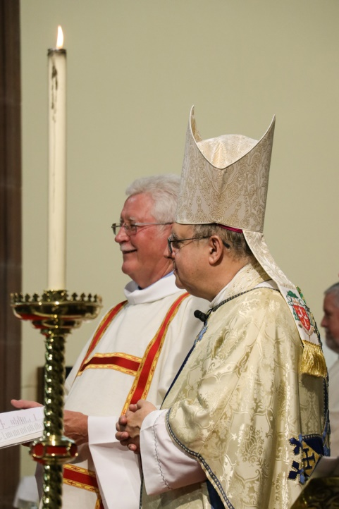
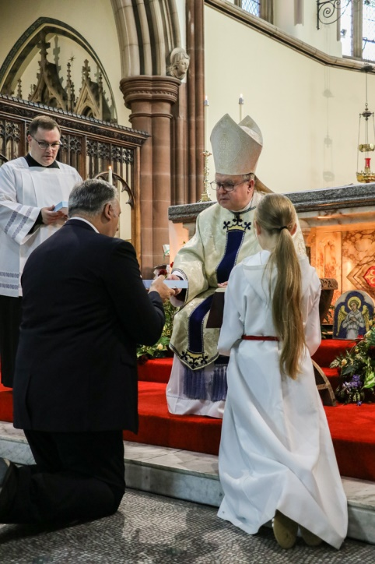
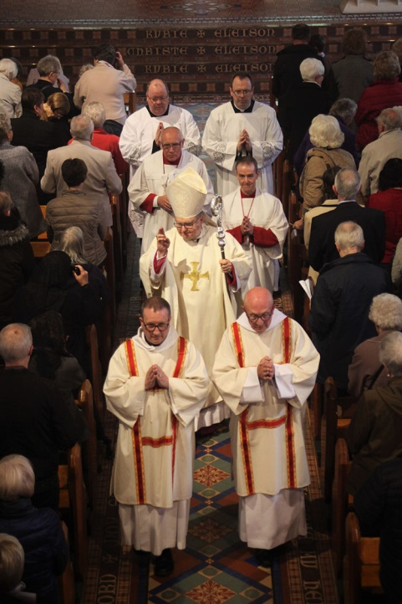
The Diaconate Ministry

The Bishop and the Deacon
The Deacon’s primary relationship is with the bishop, so much so, that one of the earliest references to deacons tells us that deacons are ordained ‘not for priesthood but for service to the bishop.’¹³ Elsewhere deacons are described as being as close to the bishop as father and son in the care of the people – so close in fact that they are 'like one soul dwelling in two bodies'¹⁴.

Deacons (again like priests) are ordained first and foremost for the diocese and then appointed to a specific role within the diocese, which normally involves being assigned to a parish. There is no reason therefore why a deacon, whilst being appointed to a particular parish, should not also have a wider commitment to minister in a group of parishes or within a deanery. His skills, circumstances and experience might be such that the bishop could ask him to take on a diocesan role e.g. in the Curia, the Marriage Tribunal or as his secretary.

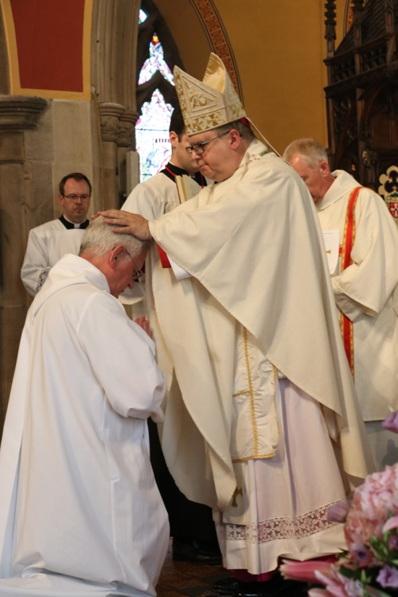

13Traditio Apostolica 1,9; trans. B.S. Easton. The Apostolic Tradition of Hippolytus (Macmillan) 38-39
1421 R. Hugh Connolly, Didascalia Apostolorum: The Syriac Version (Oxford, Clarendon Press 1929) pp 109, 148.

The Deacon and the Diocese

The Ministry of the Word
The Bishop, during the rite of ordination, gives the book of the Gospel to the deacon saying: “Receive the Gospel of Christ whose herald you now are.” A principal function of the deacon is to collaborate with the bishop and the priests in the exercise of this ministry.

  - The deacon through his ordination has the faculty in accordance with the conditions established by law to preach everywhere¹⁶. This should be exercised with at least the tacit consent of the rector or parish priest of the parish concerned and also ‘with the humility proper to one who is servant and not master of the Word of God¹⁷.
  - According to GIRM the homily is ordinarily given by the priest who presides at the Eucharist – but a deacon or concelebrating priest may be invited to preach¹⁸. It would not be unusual for a deacon to be asked to preach at Sunday Mass on a regular basis, but there is no rigid rule on the matter.
  - Homilies should be prepared in prayer, in study of the sacred texts, in harmony with the Magisterium and in a way that is relevant to those to whom they preach.¹⁹
  - This Ministry of the Word also embraces assisting the people to grow in their knowledge of their faith in Christ and to express it in their family, professional and social lives. For this reason a deacon must give attention to catechesis at all stages of Christian living.
  - The ministry of the Word is also essentially a ministry lived out beyond the church building. The deacon especially is seen as the herald of a new evangelisation transmitting the Word in his working and professional lives either explicitly or merely by his active presence in places where public opinion is formed and ethical norms are applied, such as social services or organisations promoting the rights of the family or the right to life.
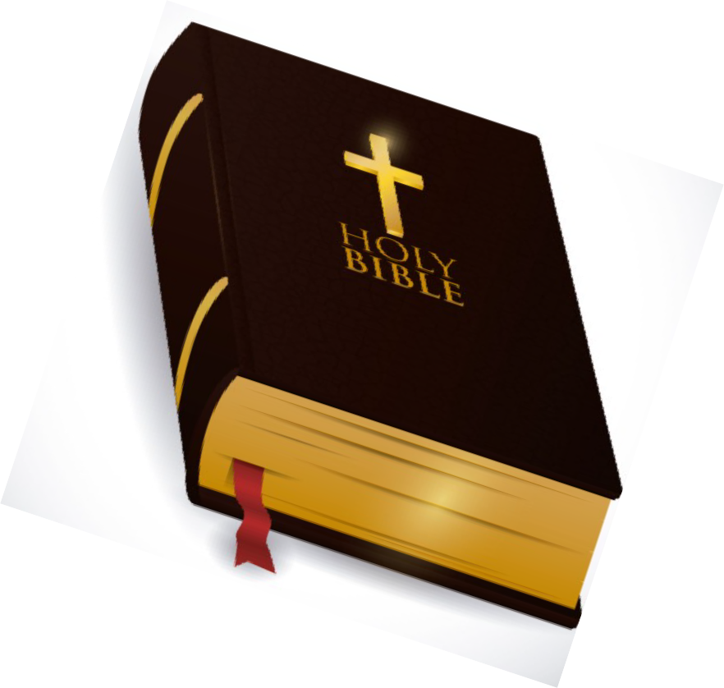
  - Through his working life the deacon, ‘to the extent that he is present and more involved than the priest in secular environments and structures, should feel encouraged to foster closeness between the ordained ministry and lay activities, in common service to the kingdom of God

15DMLPD 41 & 42
16DMLPD 24 also Canon 764
17ibid
18GIRM 66
19Directory for the Ministry and Life of Permanent Deacons (DMLPD)

The Ministry of the Altar
- After the priest, by virtue of his ordination, the deacon holds first place among those who minister at the altar; it is preferable that he usually assists daily at Mass if possible. The degree of his diaconal participation in both dress and style would be determined by the solemnity of the celebration.
- The celebration of Mass. At Mass it is the deacon’s role to:

- Carry the book of the Gospels prominently.
- Proclaim the penitential litany (at the discretion of the celebrant).
- Proclaim the Gospel.
- Give the homily (occasionally at the discretion of the celebrant).
- Prepare the altar and assist the celebrant to receive the gifts.
- Mix the water with the wine and hand the bread and wine to celebrant (saying the accompanying prayer quietly).
- Incense the celebrant and people.
- Stand near (slightly behind) the priest during the Eucharistic Prayer.
- Either kneel or bow profoundly from the epiclesis until after the elevation of the chalice (physical ability will determine which).
- Hold the chalice aloft at the same level as the priest holds the paten during the doxology.
- Invite the people to exchange the sign of peace after the priest has said the words: ‘the peace of the Lord be with you always’.
- Assist the priest, if necessary, with the fraction.
- Receive Holy Communion under both kinds.
- Assist in the distribution of Holy Communion and administer the chalice if communion is given under both kinds.
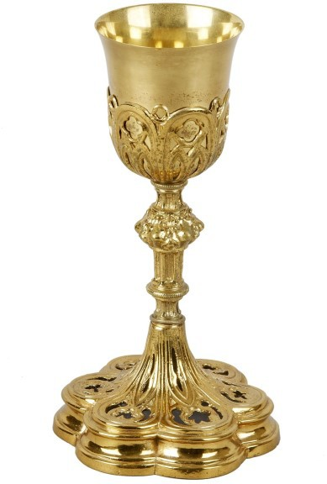
- Purify the vessels if appropriate, ensuring the sacred species are consumed. Alternatively the vessels may be left on a credence table to be purified after the Mass is finished.
- Make any announcements after the post-communion prayer, unless the celebrant prefers to do this himself.
- Instruct the people to bow their heads if a solemn prayer of blessing is used.
- Dismiss the people after the final blessing.
- Venerate the altar with the priest and accompany the priest and other ministers as they leave the altar.
- He should no longer act as MC or take on any other role within the sanctuary
other than deacon. However if no other server is present, he fulfils the duties of other ministers.

Liturgical Dress

The appropriate dress for a deacon depends on the solemnity of the occasion and his role within the specific celebration.
- For ordinary weekday Mass, an alb and stole is appropriate.
- For Solemnities and Sunday celebrations, alb, stole and dalmatic is correct
- For Liturgies of the Word, Baptism, Funerals, the Liturgy of the Hours and Marriages, a cassock, cotta and stole, or alb and stole would be appropriate; with more solemn

celebrations an alb, stole and dalmatic may be worn.
- For exposition of the Blessed Sacrament and Benediction it is appropriate to wear a cope over the alb and stole.

Clerical Dress
This may appropriately be worn when carrying out specifically diaconal duties: attending funerals, visiting the sick in hospital, prison visiting, ecumenical occasions, formal visiting of homes in the parish or attendance at parish or diocesan functions specifically as a deacon. It is not considered appropriate to wear clerical dress at a place of secular employment.
- The Deacon as an ordinary minister
- As an ordinary minister of baptism, marriage and communion and as one able to preside at Benediction, funeral services, the Hours and Liturgies of the Word, it is right, depending upon the needs of the parish, that the deacon take his turn at presiding at these liturgical celebrations. In the case of marriage and funeral liturgies it is only in the absence of a priest that the deacon should preside.
- When there is no priest available to celebrate Mass, the deacon should gather the people at an appropriate time to celebrate either Morning or Evening Prayer or a Liturgy of the Word from the Mass of the day, with or without the distribution of Holy Communion according to norms laid down by the diocese.
- It is important to keep in mind that the deacon is not ordained to replace participation by
the lay faithful but to facilitate it. So deacons appropriately enable formation to altar servers, readers, and extraordinary ministers of Holy Communion.

- Blessings. It is quite appropriate that, when presiding, a deacon give a blessing in accordance with the prescribed liturgical norms. He may also bless people who present themselves for a
blessing at Holy Communion. It is also appropriate, in the absence of a priest, that he imparts a
blessing at the end of a meeting or parish gathering. He may also bless water, crucifixes and other religious artefacts, bless homes and all objects as specified in the book of blessings.

The Ministry of Charity

- As the Servant of Charity, the deacon should lead the way in making the parish in which he serves, aware and sensitive to the needs of the poor and to issues of Justice and Peace.

- Even though the deacon according to the provisions of Canon 288 (unlike a priest or bishop) is not forbidden from running for public office or playing an active role in a political party or a trade union, the teaching of Pope Benedict in ‘Deus caritas Est’ is especially relevant. Pope Benedict distinguishes between Christian charitable activity and programmes of social action driven by political parties or ideologies: ‘The Christian’s programme - the programme of the Good Samaritan, the programme of Jesus - is “a heart which sees”. This heart sees where love is needed and acts accordingly. Obviously when charitable activity is carried out by the Church as a communitarian initiative, the spontaneity of individuals must be combined with planning, foresight and cooperation with other similar institutions. If an ordained deacon is considering putting himself forward for such public office, he should first discuss this with the Director for the Permanent Diaconate.

- As a minister who is especially called to promote harmony and unity, the deacon should have a special interest in promoting ecumenical and interfaith collaboration.

- The deacon’s ministry of charity should lead him to have a special concern for the young and the vulnerable and for those pushed to the margins of life through addiction and poverty. Again the
teaching of Pope Benedict is pertinent: ‘Charity, furthermore, cannot be used as a means of engaging in what is nowadays considered proselytism. Love is free; it is not practised as a way of
achieving other ends. But this does not mean that charitable activity must somehow leave God and Christ aside. For it is always concerned with the whole man. Often the deepest cause of suffering is the very absence of God. Those who practise charity in the Church’s name will never seek to
impose the Church’s faith upon others. They realise that a pure and generous love is the best witness to the God in whom we believe and by whom we are driven to love. A Christian knows
when it is time to speak of God and when it is better to say nothing and to let love alone speak. He knows that God is love (cf. 1 Jn. 4:8) and that God’s presence is felt at the very time when the only thing we do is to love’.

- A deacon might be asked by the Bishop to take on a special responsibility of pastoral care for certain groups of people that do not fit within parish categories such as ‘travellers’, asylum seekers and immigrant groups, for ex-prisoners, young offenders, those suffering from drug or alcohol abuse, the mentally sick, single parent families, the divorced and remarried, and other groups that need special support and care.

- Deacons may be hospital and prison chaplains, in which case a special relationship with all the priests of an area is necessary for them to carry out their ministry. Whilst providing pastoral care and support, the deacon would rely on the collaboration and good will of local priests to ensure the celebration of the Mass, Reconciliation and the Anointing of the Sick. If a deacon is intending to visit a hospital or a prison, he should first consult the existing chaplain.

- Deacons must avoid anything that might cause confusion as to the nature of their ministry. They should not attempt to anoint people with oil, as this might be perceived as the sacramental Anointing of the Sick. They should not invite a person to confess their sins as if they were going to confession – but only in the general sense, as with the „I Confess…‟ in the penitential rites.

- Where a priest is unavailable and a person is in danger of death, the appropriate rite for a deacon to use is a penitential rite such as those used at the beginning of Mass with its prayer for absolution: ‘May almighty God have mercy on us, forgive us our sins and bring us to everlasting life.
‟As part of the preparation for this the deacon should urge the dying person to be truly contrite for their sins, and help them to make a gesture of repentance such as kissing a crucifix or an act of contrition. If possible this should be followed by Viaticum.

- Many functions, especially administrative functions that were originally diaconal functions, were taken over by the presbyterate when the diaconate ceased to be a permanent ministry. It would be wise therefore for Parish Priests with a deacon to reflect and discern which functions could better be given back to the deacon so that as a priest he might have more time to devote himself ‘to prayer and to the service of the Word’.

- Whilst a deacon may act as a spiritual director or have some other pastoral role in relation to the SVP, Legion of Mary or some other lay sodality, as a member of the clergy it may not be appropriate for the deacon to remain simply as an ordinary member of such a group.

- The deacon as ordinary minister of Holy Communion is ideally suited to organising in collaboration with the priest and the laity the care of the sick. So he may assist in training extraordinary ministers to take communion into homes, care homes and hospitals. Where possible, Communion should be taken to the sick directly from the celebration of Mass.

Other Diocesan Issues:
- Incardination into the diocese is brought about by ordination to the diaconate, prior to which the intention to serve the church in the diocese will have been expressed in writing. A deacon wishing to move from the diocese and exercise his ministry in another diocese should obtain authorisation both from the bishop and from the bishop of the diocese into which he is moving.

- Upkeep and Insurance: In this diocese it is a condition of acceptance onto the Permanent Diaconate Formation Programme that the diaconal student and later the ordained deacon can provide for his own and his family’s financial upkeep. The Deacon may claim legitimate expenses. Deacons may be employed in full time employment within the Diocese at the Bishop’s discretion and therefore will receive remuneration.. Once ordained a Deacon is insured against personal injury sustained in the course of his Ministry, and against claims made by third parties arising out of given advice or services he has provided or failed to provide.

- Resignation: As with priests, upon reaching their 75th birthday, deacons shall offer their resignation from active ministry to the Bishop, notifying the Director that they have done so.

Priest, Deacon and the Parish
Of course, all priests are ordained to the diaconate en-route to the priesthood and so diaconal service is part of their ministry too. However, once a deacon is ordained for, or sent to, a parish, then the bishop has a minister present in that place whose sole role is to be an icon of service for that community.
Both priest and deacon are sent by the bishop and are in a parish under obedience to the bishop. The bishop speaks to both and exercises his ministry directly through both.

- It is essential that both priest and deacon collaborate with each other, in their different roles, for the good of the community they both serve.
- The Parish Priest has the canonical responsibility and authority for leading the parish and ensuring its pastoral care. It is he who normally presides in the name of the bishop at the liturgy and over the parish community. The deacon should do all in his power to facilitate and serve the legitimate exercise of that leadership.
- The deacon, sent by the bishop, is the priest’s closest collaborator – this should be evident in their relationship with each other and with the parish as a whole.
- It is the Parish Priest’s role to set the tone of the parish in the celebration of the liturgy. Both he and the deacon must be guided by the norms laid down by the General Instruction on the Roman Missal. (GIRM)
- Where a deacon is appointed to the pastoral care of a parish which, because of a shortage, does not have its own parish priest, Canon Law requires that a priest be appointed as the moderator of the parish, who is given the powers and faculties of a parish priest and is its

proper pastor. The deacon assists him in the care of the parish.
- The deacon’s specific task is that of inspiring, motivating and leading others in diaconal
service of both corporal and spiritual needs. He should be in his own ministry ‘a driving force for service, or diakonia.’
- Priest and deacon should be loyal to one another, remembering that they are clergy together collaborating for the good of the people within their care. All gossip concerning each other with parishioners should be shunned.
- The priest should remember that in the deacon he has a colleague who by ordination is there to serve Christ in his people and who has himself pledged obedience to the bishop.
- Where possible, Parish Priest and deacon should spend time in prayer together.
- Priest and deacon should meet regularly and keep each other informed in a professional and respectful way.
- Priest and deacon should meet regularly with the rest of the pastoral team to plan and reflect on their pastoral work in the parish.
- The Parish Priest should ensure within the circumstances of that parish that the deacon has adequate opportunity to exercise his ministry.
- As a member of the parish clergy it is fitting, as recommended in our diocesan guidelines, that the deacon be actively involved with all parish structures, e.g. the parish finance committee and, if one exists, the parish council. The deacon, when his employment and family circumstances permit, should attend all deanery meetings.
- Canonically, all offerings belong to the parish. However, where a deacon receives a stole fee for presiding at a particular liturgy, he should receive this.
- Parish Priests should note that in-service training and retreats and any meetings at which attendance is required or expected are a legitimate charge against the parish. This applies both to the cost of the event and the travel involved. There are other events too, such as National Diaconal Assemblies where it is appropriate for the parish to meet the costs involved. Deacons who draw any form of salary from their ministry, such as hospital or prison chaplains, may pay a contribution toward the cost of such an event in proportion to the salary they draw and their own personal circumstances.

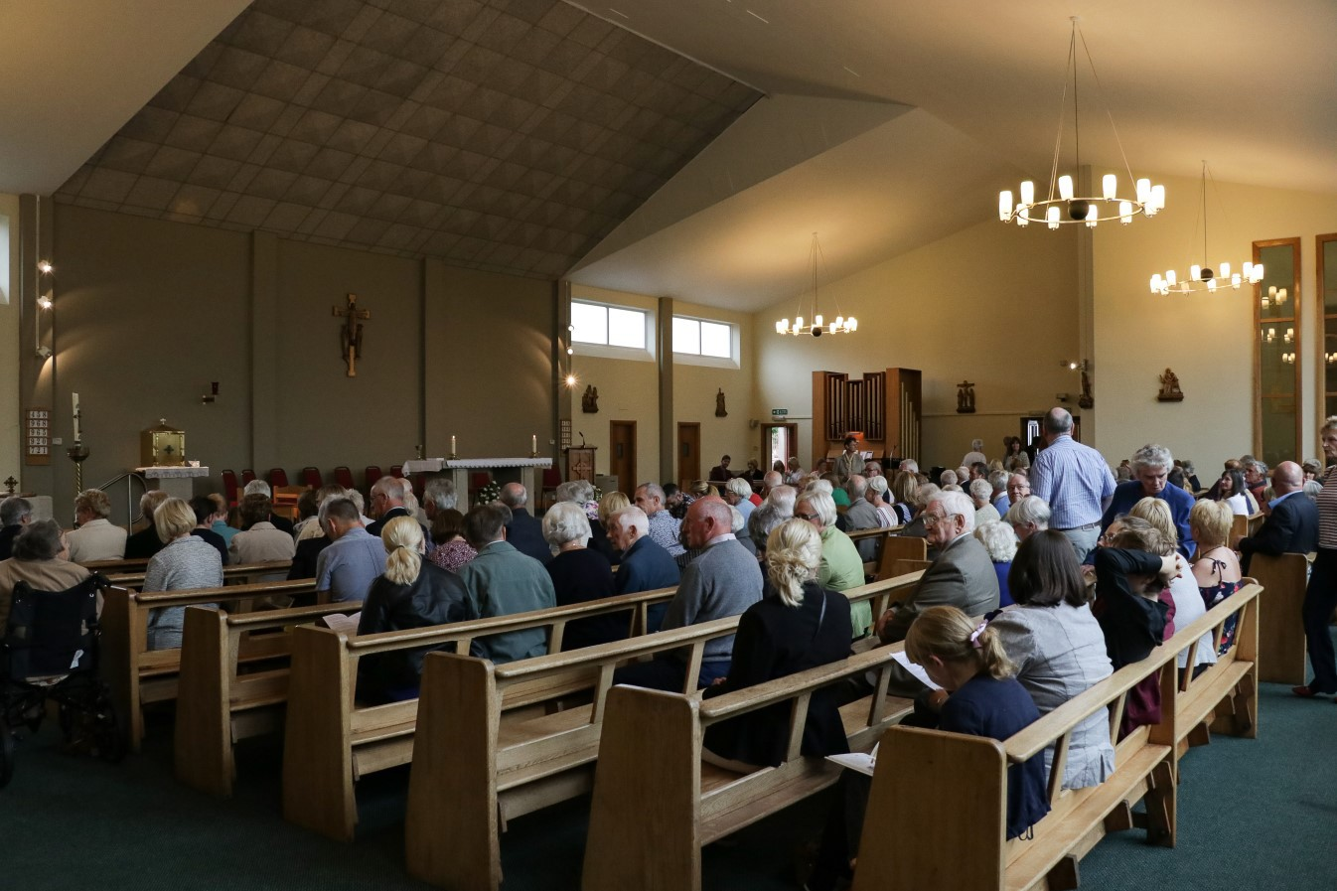

- Whilst deacons are normally not remunerated for their ministry, they are entitled to reclaim any legitimate expenses their ministry might incur, e.g., mileage or petrol allowance.
- Upon the death of a deacon the Parish Priest should notify The Bishop, the Vicar General, the Director for the Permanent Diaconate and the Dean. Whilst normally the deacon’s family would make the necessary arrangements for his funeral and meet any normal funeral expenses, it would be right and appropriate that the parish would meet the cost of any additional hospitality expenses incurred or expenses relating to the funeral liturgy itself.
- During the Funeral Liturgy, it is appropriate that the body of the deacon, as with priests and bishops, be placed in the position, which as a sacred minister he occupied in the liturgical assembly, viz., facing the people.

Moves and Changes

New Parish Priest

- Where there is a change of parish priest it would be helpful for the new priest and deacon to meet together as soon as possible. Together they should go through this handbook and clarify any issues they perceive as presenting a difficulty for each other.

- When a new parish priest arrives it would be helpful for the deacon to ask him what would be his preferred way of doing things.

- New parish priests need to be aware that the deacon can often be seen to represent continuity in the clergy of the parish. It would be good and wise management to consult with such a person in trying to understand the nature of the community that makes up the parish.

- Difficulties may arise if the new priest perceives the deacon as being the previous parish priest’s man, especially if the deacon had been put forward for ordination by him. The deacon needs to avoid giving this impression and should, as always, present himself as a deacon of the diocese and a man of the Church. The deacon must be the one who helps the parish to embrace their new priest and assists him in taking up the reins of leadership.

Induction of a Deacon into a Parish
When a deacon moves from one parish to another, or where a deacon’s formation and ordination has taken place outside the parish where he is to serve, there needs to be a process of induction. The parish priest should speak about the diaconate at Masses prior to the deacon taking up his appointment. A proper catechesis needs to be given to the people on the role and function of a deacon in a parish. It would be appropriate to hold a ceremony of welcome for the deacon during which the deacon could proclaim his commitment to serve the Church in that parish.
In a parish that has put forward and sponsored a candidate for the diaconate, it is important that, as the candidate proceeds through the formation process, so too the parish community is aware and to some extent participates in the formation process. In this way the parish will be properly catechised on the role and function of the deacon and be the more able to benefit from his ministry after ordination.

Deacons from outside the Diocese
When a deacon moves into this diocese from another, it would be normal to have a period of at

least two years before formal incardination into the diocese takes place. Any formal appointment to a parish would need to be for a limited period, renewable on a regular basis and made permanent by the process of incardination. Before even a temporary appointment is made, some form of induction process needs to take place whereby the Director for Diaconate meets the deacon and discusses with him the customs and policies of the diocese and introduces him to other deacons in the area where he resides.

A deacon coming from another diocese should study the Diocesan Handbook on the Diaconate.

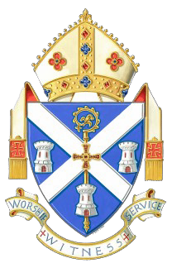
Council of Permanent Deacons

Statutes

- Nature and Purpose of the Council

  - The Council of Deacons is established to provide a forum of discussion concerning the ministry of the Order of the Permanent Diaconate and its contribution to the life of the diocese.

  - The Council is to assist the Bishop, in accordance with the law, in the pursuance of those matters pertaining to the good of the church so that the pastoral welfare of the Diocese may be effectively communicated and promoted. (Canon 212 §2 §3)

- Membership of the Council

  - Membership of the Council is open to all Permanent Deacons incardinated into the Diocese and is made up of ex officio and appointed members.

  - Ex Officio Members:
The following shall be ex officio members: the Bishop, Permanent Deacons incardinated into the Diocese of Hexham & Newcastle.

  - Appointed Members:
The following are appointed members to the Council: The Diocesan Director of Diaconate Ongoing Formation.

  - The Bishop may appoint other Priests to the Council and indicate the term and purpose of their appointment.

- Officers of the Council

  - The Bishop shall be the President of the Council.

  - The Council shall elect a Chair from among the Deacons.

  - The Office of Chair shall be for a 2 year term of office with a maximum of 2 consecutive terms.
  - A Secretary shall be elected from among the Council.

  - The Office of Secretary shall be for a 2 year term of office with a maximum of 2 consec- utive terms.

  - It is the Secretary’s function:
- To make arrangements for the Council meetings.

To advise members of meetings, and in consultation with the Bishop, to send out the Agenda.
- To minute the meetings of the Council and to provide copies of the minutes to Council members.

  - The Chairman and Secretary will meet with the Bishop to review the arrangements and procedures of the Council, as necessary.

- The Procedure of the Council

  - The Council will ordinarily meet twice a year. Extra-ordinary meetings may be called by the Bishop.

  - The Council will discuss proposals or other matters put to it by the Bishop, the
Diocesan Director of Diaconate Ongoing Formation, individual Deacons or members of the Lay Faithful.

  - The Bishop may consult the Council on any matters concerning the promotion of the Pastoral welfare of the Diocese and any matter proposed by him shall take precedence in the Agenda of the Council.

- The Agenda

  - The business of the Council will normally derive from matters proposed either by the Bishop, the Diocesan Director of Diaconate Ongoing Formation, individual Deacons and/or members of the Lay Faithful.

  - The Bishop, The Chairman and Secretary of the Council shall prepare the agenda of meetings.

All items for discussion in the Council must be submitted to the Secretary of the Council not later than one month before the meeting. Explanatory notes shall accompany all items for discussion, unless in the opinion of the Secretary such clarification is not needed.

- Resolutions of the Council

Since the function of the Council is consultative, no resolution, even if adopted unanimously, can have effect until accepted and promulgated by the Bishop, (canon 500 §2). In no circumstances can the Council be accorded a deliberate vote, neither by the Bishop nor the Episcopal Conference.

It is for the Bishop alone to decide how the acts of the Council are to be communicated to the Priests and Faithful of the Diocese.

- Commissions of the Council

  - Commissions may be established which will meet between ordinary sessions of the Council, and help in preparation of those matters to be discussed at the Council and to make recommendations concerning proposals.

  - Experts, including members of the Lay Faithful, may be asked to help in the work of these commissions (canon 228 §2)

- Other matters

  - These Statutes may be changed, following a proposal put to the Council.

  - If the See of Hexham and Newcastle becomes vacant, the Council of Deacons shall not meet.

Rt Rev Robert Byrne CO
Bishop of Hexham and Newcastle

